OOPS LAB

Experiment -8

NAME- ANMOL YADAV SAP ID- 500083814 ROLLNO- R214220178

**Question: 1**

Write a program for searching strings for the first occurrence of a character or substring and for the last occurrence of a character or substring.

**Code:**

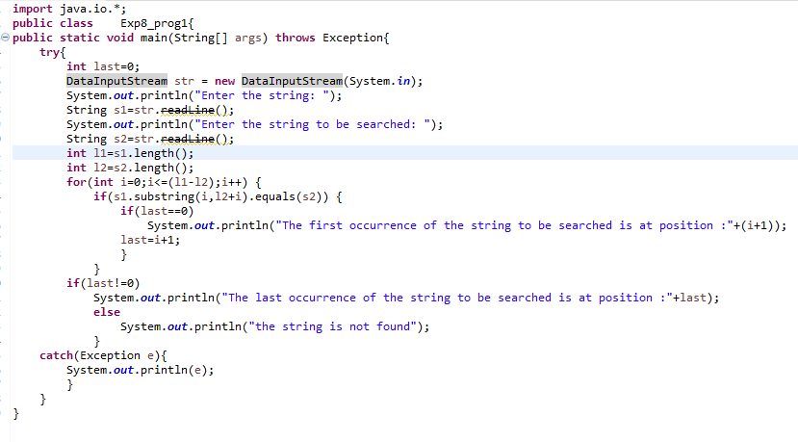

**Output:**

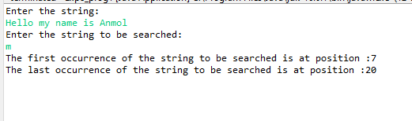

**Question: 2**

Write a program that converts all characters of a string in capital letters. (Use StringBuffer to store a string). Don’t use inbuilt function.

**Code:**

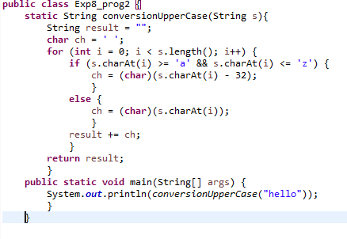

**Output:-**

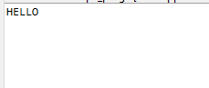

**Question: 3**

Write a program in Java to read a statement from console, convert it into upper case and again print on console. (Don’t use inbuilt function)

**Code:**

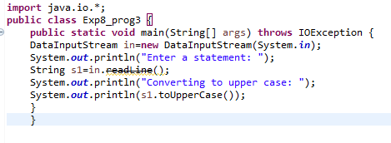

**Output:-**

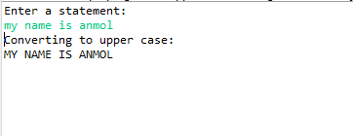

**Question: 4**

Write a program in Java to create a String object. Initialize this object with your name. Find the length of your name using the appropriate String method. Find whether the character ‘a’ is in your name or not; if yes find the number of times ‘a’ appears in your name. Print locations of occurrences of ‘a’ .Try the same for different String objects

**Code:-**

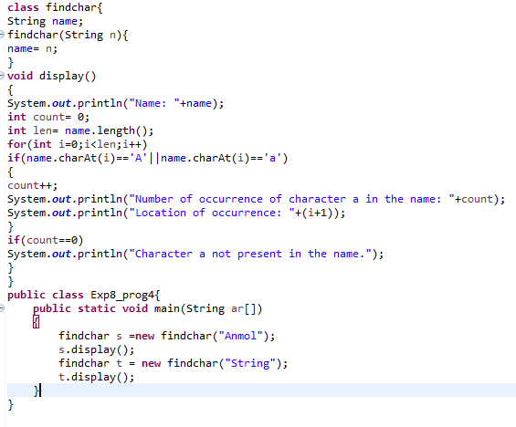

**Output:-**

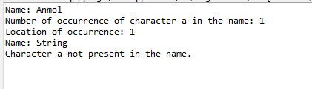

**WRAPPER CLASSES**

1. Write a Java code that converts int to Integer, converts Integer to String,

converts String to int, converts int to String, converts String to Integer

converts Integer to int.

**Code:**

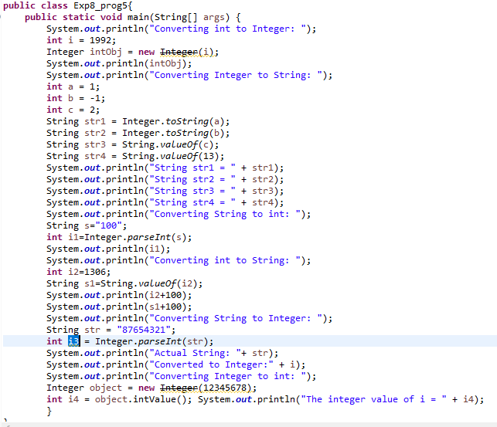

**Output:**

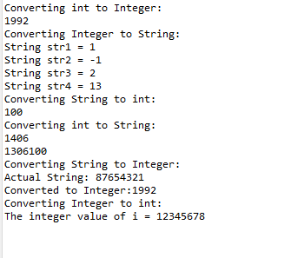

1. Write a Java code that converts float to Float converts Float to String converts String to float converts float to String converts String to Float converts Float to float.

**Code:**

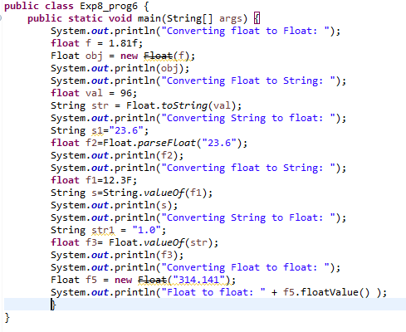

**Output:**

